LandXML Schema Version 1.0 Reference
June 12, 2002

Preliminary Draft lasted edited: 6/12/2002
Prepared for

The Land Development and Transportation Industry
LandXML Organization: http://www.landxml.org

Discussions: http://groups.yahoo.com/landxml

Prepared by

Nathan Crews, LandXML Principle Schema Architect, autodesk, Inc.
Contributing Authors:
Eric Hall, Tripod Data Systems
Dr. Danijel Rebolj, University of Maribor, Slovenia

Table of contents

Documentation Notation 3
Introduction 4
LandXML Schema 1.0 Overview 4
XML Standards Reference 4
Specification Title 4
Date 4
URL 4
Land Development Industry Standards Reference 4
aecXML (www.aecXML.org) 4
GML (Geometric Modeling Language, www.OpenGIS.org) 5
LandXML Data Model 6
LandXML Schema Structure 7
The LandXML Header and Namespace Declaration 7
Suggested Minimum LandXML Element Content 7
Adding non-LandXML Content to the Available <xs:any> Elements 8
Schema Naming Conventions 8
XML Basic Schema Syntax 8
Coordinate Text Values 9
Units of Measure 11
Numeric Data Precision 12
Coordinate Systems 13
Element Referencing 13
Required and Optional Elements 14
Common sub-Elements and Element Attributes 15
Element Name Uniqueness Methodology 16
LandXML Schema Semantics 18
List Type Derived Elements 18
Resolving Point References 18
Gaps in Geometry 18
External File References Provided by the LandXML Schema 19
LandXML Import/Export 19
LandXML Roadway Model 21
Describing Structural Roadway objects 26

Documentation Notation

In order to clearly identify LandXML element and specific attributes in this document the following notation has been adopted. Element names will typically appear in angle brackets, like <CgPoints>.

Specific element attributes and sub-elements are noted as <CgPoints>.name and <CgPoints>.<CgPoint>. Where <CgPoints>.name refers to the ‘name’ attribute of the <CgPoints> element and <CgPoints>.<CgPoint> indicates the <CgPoint> element is contained within the <CgPoints> element.

Where appropriate sample XML fragments will indicate additional content by using <…> to indicate that additional element content is typical. Indentation is used to clarify the sub-element content hierarchy.

For example,

<LandXML>
<Units></Units>
<…>
</LandXML>

indicates that there is child element content found between the <LandXML> element tags and these elements have a peer relationship with the <Units> element.

Introduction

This document assumes some familiarity the LandXML schema, what it is and who is involved - both of which are detailed on the LandXML web site www.landxml.org.

LandXML Schema 1.0 Overview

The LandXML schema is defined, maintained and hosted by LandXML.org, a Land Development industry organization.

Schema file name : LandXML-1.0.xsd

Schema namespace: http://www.landxml.org/schema/LandXML-1.0

Schema location : http://www.landxml.org/schema/LandXML-1.0/ LandXML-1.0.xsd

XML Standards Reference

Reference W3C (World Wide Web Consortium) XML Specifications:

Specification Title | Date | URL
XML | February 1998 | http://www.w3.org/XML
Namspaces | January 1999 | http://www.w3.org/TR/1999/REC-xml-names-19990114
XML Schema | 05-02-2001 | http://www.w3.org/XML/Schema
Xlink | 06-27-2001 | http://www.w3.org/XML/Linking
XSL | 10-15-2001 | http://www.w3.org/TR/xsl
Xpath | 11-16-1999 | http://www.w3.org/TR/xpath

Land Development Industry Standards Reference

aecXML (www.aecXML.org)

aecXML is an XML-based language used to represent information in the broad Architecture, Engineering and Construction (AEC) industry. This information may be resources such as projects, documents, materials, parts, organizations, professionals or activities such as proposals, design, estimating, scheduling and construction. It is intended to be used as an XML namespace and to facilitate information exchange of AEC data on the Internet

LandXML design data can be contained in an aecXML data file:

<aecXML>
<Project>
<ApplicationData>
<lx:LandXML xs:xmlns:lx=“http://www.landxml.org/LandXML-1.0”
<lx:LandXML elements here/>
</lx:LandXML>
</Application Data>
</Project>
</aecXML>

GML (Geometric Modeling Language, www.OpenGIS.org)

Geographic Markup Language (GML) is an XML-based language developed by the Open GIS Consortium (OGC), an international organization founded in 1994 to promote interoperability in geographic information systems (GIS).

GML provides coordinate (projection, geographic and geocentric) systems and simple features geometry model. Transforming LandXML design data to GML provides a way to propagate complex Land design geometries into GIS databases.

LandXML Data Model

The following is the alphabetized LandXML data structure hierarchy of root nodes.

Links to LandXML schema documentation (LandXML-1.0.doc)

LandXML
Alignments
Application
CgPoints
CoordinateSystem
GradeModel
Monuments
Parcels
PipeNetworks
PlanFeatures
Project
Roadways
Surfaces
Survey
Units

Links to details

LandXML
Alignments
Application
CgPoints
CoordinateSystem
GradeModel
Monuments
Parcels
PipeNetworks
PlanFeatures
Project
Roadways
Surfaces
Survey
Units

LandXML Schema Structure

This section will document the XML schema conventions used and not used by LandXML along with the general XML structure of a LandXML data file.

The LandXML Header and Namespace Declaration

This XML header, or outer most <> tags should encapsulate LandXML element content.

<LandXML xmlns="http://www.landxml.org/schema/LandXML-1.0" xmlns:xsi="http://www.w3.org/2001/XMLSchema-instance" xsi:schemaLocation="http://www.landxml.org/schema/LandXML-1.0 http://www.landxml.org/schema/LandXML-1.0/LandXML-1.0.xsd" version="1.0" date="2002-01-28" time="10:16:46" readOnly="false" language="English">
<…>
</LandXML>

Suggested Minimum LandXML Element Content

While the above illustrates the absolute minimum valid LandXML header, the following is most strongly suggested. The design data needs context:

<LandXML xmlns="http://www.landxml.org/schema/LandXML-1.0" xmlns:xsi="http://www.w3.org/2001/XMLSchema-instance" xsi:schemaLocation="http://www.landxml.org/schema/LandXML-1.0 http://www.landxml.org/schema/LandXML-1.0/LandXML-1.0.xsd" version="1.0" date="2002-01-28" time="10:16:46" readOnly="false" language="English">
<Project name="ROUTE202" desc="Hillsboro Bypass Phase 2"/>
<Units>
<Imperial linearUnit="foot" areaUnit="squareFoot" volumeUnit="cubicYard" temperatureUnit="fahrenheit" pressureUnit="inHG" angularUnit="decimal degrees" directionUnit="decimal degrees"/>
</Units>
<Application name="Land Desktop" manufacturer="Autodesk" version="3 - Service Pack 1" manufacturerURL="www.autodesk.com" timeStamp="2002-05-09T07:17:00">
<Author createdBy="Nathan Crews" createdByEmail= "nathan.crews@autodesk.com" company="Autodesk, Inc." companyURL="www.autodesk.com" timeStamp="2002-05-09T07:17:00.000-05:00"/>
</Application>
</LandXML>

Where xmlns=”http://www.landxml.org/schema/LandXML-1.0” declares the default namespace for the document and xmlns:xsi=”http://www.w3.org/2001/XMLSchema-instance” allows the use of the xsi:schemaLocation=”http://www.landxml.org/schema/LandXML-1.0 <single blank space here> http://www.landxml.org/schema/LandXML-1.0/LandXML-1.0.xsd” attribute to specify the location of the LandXML schema file for the declared namespace. This schema location is used during data validation and tells the XML parser where to look up the schema file.

In addition to the LandXML header, <Project>, <Units>, <Application> and <Author> are also present. The consistent inclusion of these elements gives the data strong context since it answers the classic question “who what when and why?” and of course, without units of measure the numeric values have little value.

Adding non-LandXML Content to the Available <xs:any> Elements

There are seven elements where free-form, non-LandXML data may be contained and still validate. These occur in the <LandXML>, <Project>, <CoordinateSystem>, <Feature>, <Application>, <Author> and <FieldNote> elements.

In order to validate under strict XML Schema rules, an XML namespace must be provided for the content. For example
<Project name="Shaker">
<foo:NewElements xs:xmlns:foo="schema-foo">
<foo:MoreNewElements withattributes="value">Some cdata content here</foo:MoreNewElements>
</foo:NewElements>
</Project>

adds an element sub-structure in the foo namespace that is related to the LandXML <Project> element. This allows non-LandXML schema data to associated with specific LandXML elements within one data file.

Schema Naming Conventions

Element names follow the “upper camel case” naming convention. The name starts with an upper case character and any joined words also start with upper case characters. Some words may be abbreviated such as Station as ‘Sta’, description as ‘desc’ and Point as ‘Pnt’.

Examples: CgPoints, SourceData, Units.

Attribute names follow the “lower camel case” naming convention where the name starts with a lower case character and any joined words start with upper case characters. Some words may be abbreviated.

Examples: linearUnit, dirStart, name.

The most extreme case of abbreviation in the LandXML schema is with the point and face elements in the TIN Surface definition. Because a surface may contain hundreds of thousands of points, the surface point element (containing the northing, easting, elevation values) was abbreviated to P and the face element (containing the point id’s that define the face) was abbreviated to F to minimize the file size when hundreds of thousands of <P> and <F> records may be present in a large surface model.

Note: element and attribute names are case sensitive. An attribute named LinearUnit is not the same as linearUnit and is considered an invalid entry.

XML Basic Schema Syntax

An element is a named item in an XML file that is enclosed within angle brackets, typically forming a tag pair. The term ‘tag’ is borrowed from HTML and is commonly used in XML notation. For example:

<Line></Line>

An element may contain attribute values and may have either a text value or sub-elements. An element can’t contain both a text value and sub-elements.

If an element does not contain a text value or sub-elements, then there is a forward slash immediately preceding the closing angle bracket.

<Line length="102.320" dir="3.454187" />

If an element contains a text value or sub-elements, this content appears between two matching element tags. The first element tag indicates the start of the element and contains any attributes but does not contain the ending forward slash. The second tag indicates the end of the element and follows the text string or sub elements. It has a forward slash preceding the element name.

Unlike element names and attributes, a text value is a string that is not contained within the angle brackets. Instead it is contained within matching element tags. The following example shows an element that has a “northing easting” text value.

<Start>1852.9558 1649.6982</Start>

This Start element is a sub-element of a Line element and would appear as follows.

<Line length="102.320" dir="3.454187">
<Start>1852.9558 1649.6982</Start>
<End>1821.4887 1552.3344</End>
</Line>

Coordinate Text Values

Coordinate text values in the LandXML file are space-delimited strings that hold horizontal location information in the form of “Northing Easting Elevation”. Northing is the Y coordinate value, easting is the X coordinate value and elevation is the Z coordinate value. Additional coordinate values in profile and cross section geometries appear as “offset elevation” pairs.

The elevation value is optional with many of the “northing easting elevation” elements, such as the <CgPoint>, <Start>, <Center> and <End>. Others, such as the <Surface>.<…>.<P> element require the elevation value along with the northing and easting.

The following is a <Start> element with a “northing easting” text value and one with a “northing easting elevation”:

A 2D point: <Start>1852.9558 1649.6982</Start>
A 3D point: <Start>1852.9558 1649.6982 86.351</Start>

Units of Measure

Without units of measure, numeric data in the schema would be of no practical use. <Units> is a required element in any data file. The two supported unit systems are Imperial and Metric. The following units of measure and available options are provided.

LandXML Units of Measure Table (*required attributes, underlined text indicate default values).
Unit Name | Defined Imperial Values | Defined Metric Values
linearUnit * | foot  USSurveyFoot  inch  mile | millimeter  centimeter  meter  kilometer
areaUnit * | acre  squareFoot  squareInch  squareMiles | hectare  squareMeter  squareMillimeter  squareCentimeter
volumeUnit * | US_gallon  IMP_gallon  cubicInch  cubicFeet  cubicYard  acreFeet | cubicMeter  literhectareMeter
temperatureUnit * | fahrenheit  kelvin | Celsius  kelvin
pressureUnit * | inchHG  inHG | HPA  milliBars  mmHG  millimeterHG
angularUnit | radians  grads  decimal degrees  decimal dd.mm.ss | radians  grads  decimal degrees  decimal dd.mm.ss
directionUnit | radians  grads  decimal degrees  decimal dd.mm.ss | radians  grads  decimal degrees  decimal dd.mm.ss
diameterUnit | foot  USSurveyFoot  inch | millimeter  centimeter  meter  kilometer
widthUnit | foot  USSurveyFoot  inch | millimeter  centimeter  meter  kilometer
heightUnit | foot  USSurveyFoot  inch | millimeter  centimeter  meter  kilometer
velocityUnit | feetPerSecond  milesPerHour | metersPerSecond  kilometersPerHour
flowUnit | US_gallonPerDay  IMP_gallonPerDay  cubicFeetDay  US_gallonPerMinute  IMP_gallonPerMinute  acreFeetDay  cubicFeetSecond | cubicMeterSecond  literPerSecond  literPerMinute

Example

<Units>
<Imperial linearUnit="foot" areaUnit="squareFoot" volumeUnit="cubicYard" temperatureUnit="fahrenheit" pressureUnit="inHG" angularUnit="radians" directionUnit="radians"/>
</Units>

Numeric Data Precision

There are no restrictions on the precision of the numeric values in the LandXML schema but there are suggested guidelines, depending on the intended use of the data and the data type.

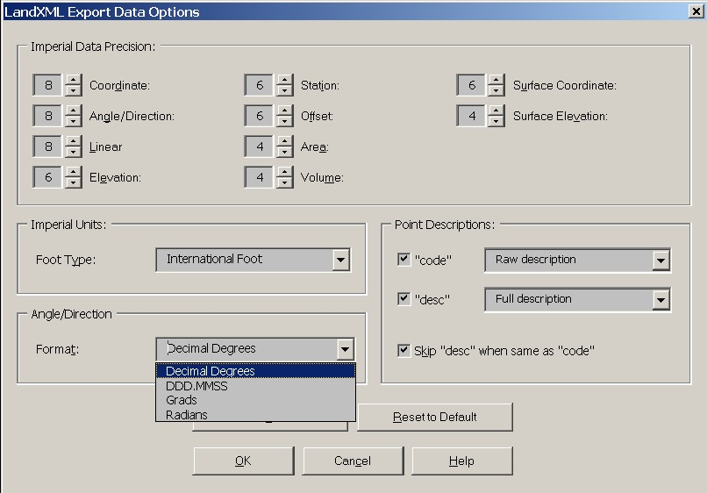

If the LandXML file is to be used for translating data between different software programs or for archival purposes then a greater precision is required then if the file is to be used for report generation.

NUMERIC TABLE HERE, To be completed…

Coordinate Systems

<CoordinateSystem>.xxCoordianteSystemName attributes were gather from the OpenGIS Coordinate System interface descriptions and the values of the names should be the OpenGIS common use name for the coordinate system. The OpenGIS coordinate systems XML description may still be appended to this element and validate.

<xs:element name="CoordinateSystem">
<xs:complexType>
<xs:sequence>
<xs:element ref="Start"/>
<xs:element ref="Feature" minOccurs="0" maxOccurs="unbounded"/>
<xs:any processContents="lax"/>
</xs:sequence>
<xs:attribute name="fileLocation" type="xs:anyURI" use="required"/>
<xs:attribute name="desc" type="xs:string"/>
<xs:attribute name="name" type="xs:string"/>
<xs:attribute name="rotationAngle" type="angle"/>
<xs:attribute name="datum" type="xs:string"/>
<xs:attribute name="horizontalDatum" type="xs:string"/>
<xs:attribute name="verticalDatum" type="xs:string"/>
<xs:attribute name="ellipsoidName" type="xs:string"/>
<xs:attribute name="fittedCoordinateSystemName" type="xs:string"/>
<xs:attribute name="horizontalCoordinateSystemName" type="xs:string"/>
<xs:attribute name="compoundCoordinateSystemName" type="xs:string"/>
<xs:attribute name="localCoordinateSystemName" type="xs:string"/>
<xs:attribute name="geographicCoordinateSystemName" type="xs:string"/>
<xs:attribute name="projectedCoordinateSystemName" type="xs:string"/>
<xs:attribute name="geocentricCoordinateSystemName" type="xs:string"/>
<xs:attribute name="verticalCoordinateSystemName" type="xs:string"/>
</xs:complexType>
</xs:element>

Where the fileLocation attribute is required. This attribute should contain the actual coordinate system file used. These coordinate system files are may be public-use or proprietary. This follows the OpenGIS recommendation on referencing the coordinate system model parameters for any type of coordinate system.

Element Referencing

Inherent in any data structure is a need to reference other parts of the data structure. For example, this allows a storm drainage pipe to reference the control structures it is connected with and vise versa.

In addition to general element referencing available in W3C’s XPath specification, there are explicit element references built into the LandXML schema. These explicit element references are either required to fully transmit certain data structures or are provided for convenience.

The following simpleTypes have been added to make LandXML element ‘name’ attribute referencing less ambiguous.

pointNameRef pointNameRefs
cgPointsNameRef cgPointsNameRefs
alignmentNameRef alignmentNameRefs
surfaceNameRef surfaceNameRefs
parcelNameRef parcelNameRefs
coordGeomNameRef coordGeomNameRefs
pipeNameRef" pipeNameRefs
structNameRef structNameRefs
monumentNameRef
waterShedNameRef

For example consider the <CgPoint> and other <PointType> derived elements:

<xs:complexType name="PointType" mixed="true">
<xs:simpleContent>
<xs:restriction base="Point">
<xs:minLength value="0"/>
<xs:maxLength value="3"/>
<xs:attribute name="name" type="xs:string"/>
<xs:attribute name="desc" type="xs:string"/>
<xs:attribute name="code" type="xs:string"/>
<xs:attribute name="state" type="stateType"/>
<xs:attribute name="pntRef" type="pointNameRef"/>
<xs:attribute name="pointGeometry" type="pointGeometryType"/>
<xs:attribute name="DTMAttribute" type="DTMAttributeType"/>
<xs:attribute name="timestamp" type="xs:dateTime" use="optional"/>
<xs:attribute name="role" type="surveyRoleType" use="optional"/>
</xs:restriction>
</xs:simpleContent>
</xs:complexType>

The “pntRef” attribute is now of type “pointNameRef”, which is less ambiguous than the previous definition of type “string”. That is the value of “pntRef” should indicate a “name” attribute in a <PointType> derived element.

Required and Optional Elements

Not all of the LandXML elements are required to exist in a valid LandXML data file. The LandXML root element is required, and there can be only one occurrence in a LandXML file. The only required child element of the <LandXML> root element is <Units>. All other elements are optional.

<LandXML version="1.00" date="2001-07-15" time="08:21:52>
<Units>
<Imperial linearUnit="foot" areaUnit="squareFoot" volumeUnit="cubicYard" temperatureUnit="fahrenheit" pressureUnit="inHG" angularUnit="radians" directionUnit="radians"/>
</Units>
</LandXML>

While it is possible to have a LandXML file that only contains a Units element it wouldn’t be of much practical use without any of the data elements.

Elements may be optional, or they may be required. An optional element may have required sub-elements. For example, Parcels is an optional element of the LandXML Schema, but if it exists it must contain at least one Parcel element.

An element may be limited to one occurrence within it’s parent element, or multiple instances.

In some instances a number of LandXML data files may be used to segment large amounts of data or types of data. For example, a set of LandXML files could be used to transmit or archive a single <Surface> definition.

The simplest and required form of a LandXML data file:

<LandXML version="1.00" date="2001-07-15" time="08:21:52" readOnly="false" language="English" LandXMLId="124">
<Units>
<Imperial linearUnit="foot" areaUnit="squareFoot" volumeUnit="cubicYard"/>
</Units>
</LandXML>

Common sub-Elements and Element Attributes

There a number of common sub-elements and attributes that are used though out the LandXML schema. Most of these are optional.

Element Attributes:

name String - alpha-numeric identifier for the element type.
desc String - alpha-numeric
state Enumeration - proposed, existing, abandoned, destroyed

Elements:

The <Feature> element is a generic method to annotate physical or logical attributes (or properties) of any LandXML element.

Most LandXML elements may contain 0 to n <Feature> elements. Each <Feature> has a required ‘code’ value and may contain 0 to n <Property> elements. Each <Property> element contains two required attributes, ‘label’ and ‘value’. The ‘label’ attribute identifies <Property> and the ‘value’ attribute contains the value in text form.

Example:

<CgPoint name="11" state=”existing”>315790.857525385
4839057.57432995 118.839
<Feature code="tree">
<Property label="Diamater" value="1.54"/>
<Property label="DripRadius" value="12.5"/>
</Feature>
</CgPoint>

<CgPoint name="10" state=”proposed”>315518.062855579
4839084.29408032 128.138
<Feature code="Property Corner">
<Property label="note" value="IP in poor condition"/>
</Feature>
</CgPoint>

Element Name Uniqueness Methodology

Unique names resolve using simple xpath syntax and instance data will validate using tools such as XMLSpy version 4.2 or above. Unique “name”, “id” and “sta” attributes are scoped to element types and collections of element types. It has been agreed that this form over ID/IDREF form is better suited to our needs.

<xs:selector xpath="CgPoints/CgPoint"/>
<xs:field xpath="@name"/>

<xs:selector xpath="Monuments/Monument"/>
<xs:field xpath="@name"/>

<xs:selector xpath="Surfaces/Surface"/>
<xs:field xpath="@name"/>

<xs:selector xpath="Surface/Definition/Pnts/P"/>
<xs:field xpath="@id"/>

<xs:selector xpath="Parcels/Parcel"/>
<xs:field xpath="@name"/>

<xs:selector xpath="Alignments/Alignment"/>
<xs:field xpath="@name"/>

<xs:selector xpath="PipeNetworks/PipeNetwork"/>
<xs:field xpath="@name"/>

<xs:selector xpath="PipeNetwork/Pipes/Pipe"/>
<xs:field xpath="@name"/>

<xs:selector xpath="PipeNetwork/Stucts/Struct"/>
<xs:field xpath="@name"/>

<xs:selector xpath="CrossSect"/>
<xs:field xpath="@sta"/>

For example, the following is NOT allowed

<CgPoints name=”topo shots”>
<CgPoint name="221">112.20158756 -42.24299875</CgPoint>
<CgPoint name="221">110.93558099 57.71138949</CgPoint>
</CgPoints>

nor is this allowed

<CgPoints name=”topo shots”>
<CgPoint name="221">112.20158756 -42.24299875</CgPoint>
<CgPoint name="222">110.93558099 57.71138949</CgPoint>
</CgPoints>
<…>
<CgPoints name=”EP shots”>
<CgPoint name="221">112.20158756 -42.24299875</CgPoint>
<CgPoint name="222">110.93558099 57.71138949</CgPoint>
</CgPoints>

Each <CgPoint>.name value must be unique with the data file, but may be the same value as an <Alignment>.name value with in the same data file.

Example:

<CgPoints name=”topo shots”>
<CgPoint name="221">112.20158756 -42.24299875</CgPoint>
<CgPoint name="222">110.93558099 57.71138949</CgPoint>
</CgPoints>
<…>
<Alignments name=”existing CL”>
<Alignment name="221">
<…>
</Alignment>
</Alignments>

This is perfectly valid. LandXML Element uniqueness has data context scoping and is not data file scope global which is less restrictive than using ID, IDREF built-in XML Schema data types.

LandXML Schema Semantics

This section will discuss the expected LandXML data structure beyond XML syntax. In all its flexibility and power, XML schema does not provide all the constraints required by LandXML. For example, there is no way to insure even sets of tuples exist in the <PntList3D> element.

List Type Derived Elements

Resolving Point References

Given that all <PointType> derived elements can reference another <PointType> derived point for its location, optionally not containing any coordinate data itself - there is no way to insure that the referenced point actually resolves to a coordinate, since it may contain a pntRef to itself and not contain a location.

For example

<CgPoint name=”1” pntRef=”1” />
<CgPoint name=”2” pntRef=”1” />

While this makes no sense, it is still valid syntax and will not be caught by using a validating XML parser.

Gaps in Geometry

To allow gaps in the definitions of profile surfaces, cross section surfaces, or plan features such as fences, the <ProfSurf>, <CrossSectSurf> and <PlanFeature> elements support multiple PointList2D elements. If there are gaps in the definition, then the point list will be divided into separate PntList2D elements. The PntList2D elements should be in consecutive order.

For example, if a profile surface had a gap between station 0+200 and 0+240, it would be represented as

<ProfSurf name=”eg”>
<PntList2D>1852.9558 1649.6982</ PntList2D >
</ProfSurf>

The <CoordGeom> element is a consecutive collection of lines, curves and spirals. Normally they are connected with the end of one element having the same location as the start of the next. If they are not the same, then there is a gap in the geometry. This situation should be watched for and handled when reading the file.

External File References Provided by the LandXML Schema

A simple alternative to external file linking has been provided in the LandXML schema for specific elements. These optional LandXML elements refer to larger source data files used to create the LandXML data elements.

Example:
<…>
<Surfaces>
<Surface name=”EG” desc=”Existing Ground”>
<…>
<SourceData>
<PointFiles>
<PointFile>d:\\projects\\cityofmoosehead\\1020Points.xml</PointFile>
<PointFile>http://data.rosecounty.st.me.us/planning/50gridtopopoint.asp?city=moosehead
</PointFile>
</PointFiles>
</SourceData>
<…>
</Surface>
</Surfaces>

This example shows two types of external references, one is a XML document located on the local file system and the second is a XML stream generated by the specified URL. Both types of reference return LandXML data containing surface point <P> elements.

The <Feature>.<DocFileRef> element is contained within the common <Feature> element. Using this element, it is easy to associate external data, such as raw data files, drawing files, project files, legal documents or even web data references such as links to DEM and other surface data, to specific elements.

LandXML Import/Export

A few guidelines can address a number of issues when attempting to preserve data integrity when importing and exporting data between two dissimilar systems. These are guidelines and not rules as to how to implement a system that supports LandXML data interoperability.

In general, when exporting a LandXML data structure back to an original data structure, change only the modified elements and attributes.

For example:

To rename the parcel element from “Lot #1” to “Parcel 1”. All of the original data should be left intact and just the attribute value for /Parcel@name should be modified.

<…>
<Parcel name="Lot 1" area="41278.2993936443">
<Center>1316.52447736 -518.25876507</Center>
<CoordGeom>
<Line>
<Start pntRef="141"/>
<End pntRef="135"/>
</Line>
<…>
</CoordGeom>
<…>

LandXML Roadway Model

The complete LandXML 3D roadway model is defined by three elements: <Roadway>, <Alignment> and <GradeModel>.

The <Roadway> element represents the FHWA IHSDM road model incorporating AASHTO representations of roadway data. This data includes design speed, road lanes, roadside elements (guardrail, signage and lighting), intersections and crash history. The <Roadway> element references and <Alignment> and a <GradeModel> elements for a complete 3D geometric model.

The <Alignment> element, typically representing the road design centerline, contains the horizontal and vertical geometry definitions along with superelevation, station equations and cross section output data. The cross section data is not intended to be design sections or templates, but as finished output information. The <GradeModel> is used to describe the 3D road model.

The <GradeModel> contains a series of zones that are a structure that describes a portion of the cross section of the road. Each zone runs along the alignment at the width specified in the <ZoneWidth> element and at the cross slope defined in the <ZoneSlope> element. Each zone has a starting and ending values for station, width and cross slope values. The zone can then be modified by multiple <ZoneWidth> and <ZoneSlope> elements. There is also a <ZoneCutFill> element that defines the slope stake ratio for a zone and whether to use the zone for cut slope staking, fill slope staking or both. There is also a <ZoneCrossSectStructure> used to describe both associated and free-floating structural objects in the roadway.

Example roadway with Zones:

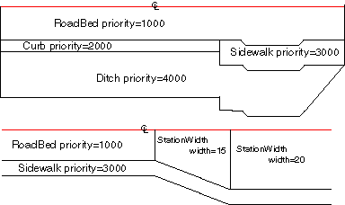

In this example, ‘RoadBed’ is a zone that follows the full length of the alignment. It’s priority is set to 1000. Zone priority is the indicator as to where the zone should be placed in reference to the centerline. The lower the number the higher the priority and the closer to the centerline the zone gets. If a zone had the priority of 1 and another zone had the priority of 2 and both the zones exist at the station in question then the zone with priority 1 will be placed next to the centerline and the zone with priority two gets placed next to the zone with priority 1.

This example also illustrates how the <ZoneWidth> element gets used. <ZoneSlope> works the same way except that it modifies the slope of the zone not the width. This means that zone width is independent from zone slope.

Zone objects and <ZoneSlope> elements also contain a vertValue attribute and a vertType attribute. vertValue is the value for the vertical change either a slope (-2.00%) or change in vertical distance. The vertType is an enumerated type that allows either “Slope” or “VertDistance”. The parabolicStartStation and parabolicEndStation attributes are used to form a parabolic transition from one slope to another.

The <ZoneHinge> element contains a hingeType attribute that is an enumerated type with values of “right edge”, “center” and “left edge”. This element identifies the zone which contains the hinge point location when changing the slope of a Zone through superelevation transitions. The hinge point should be recorded for the inital

The <GradeModel> contains an optional <Start> element to modify the starting location of an alignment. This can be used for subgrades that use the same alignment but need to be offset down a few feet. It should not be used to modify the starting location of an alignment, since design station values in the <Zone> elements would not match other design station values else where in the LandXML data structure.

<GradeModel> also contains the <Zones> element which contains all of the <Zone> objects. <Zones> also specify which side of the alignment the following <Zone> objects apply. There must be a minimum of one <Zones> object and a maximum of two – one for each side of the roadway.

<GradeModel> contains a reference to an <Alignment> element. This way you can reuse Alignment objects multiple times without having to duplicate them - this is useful for defining subgrades. The surfaceType attribute is an enumerated type that indicates either “FinalSurface” or “Subgrade”.

Roadway example:
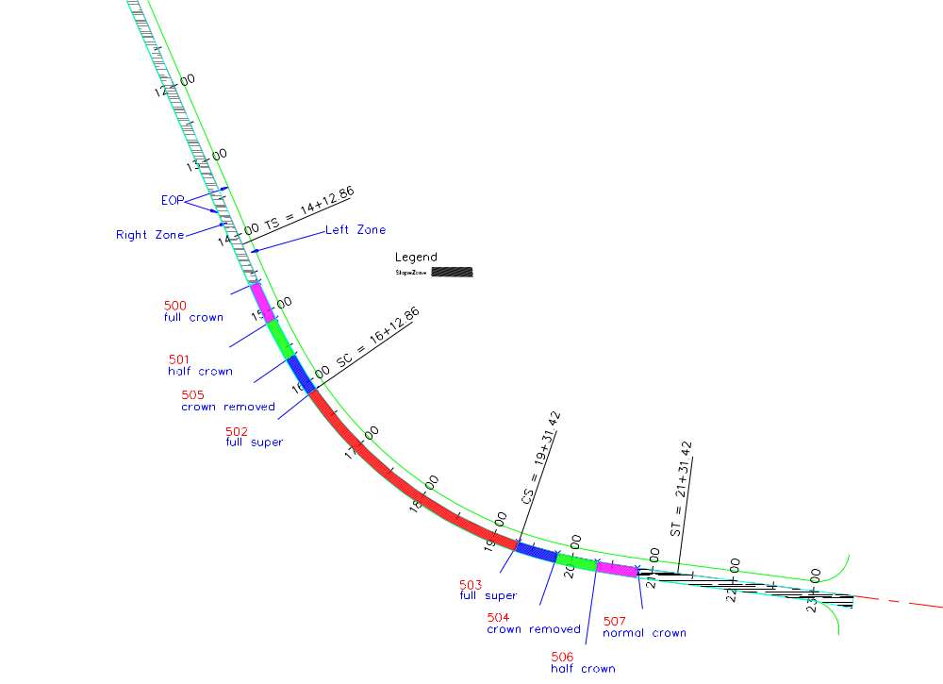

Example LandXML fragment:
<GradeModel desc="Route 202 road surface" name="Route 202" state="proposed">
<GradeSurface surfaceType="finalSurface" alignmentRef="202cl" stationAlignmentRef="202cl" name="202top" desc="road surface" state="proposed">
<Start>10000.0000 10000.0000</Start>
<Zones side="right" desc="right road way surface" name="roadway-right" state="proposed">
<Zone desc="road surface" name="rightroadsurface" state="proposed" priority="1000" category="road surface" staStart="1000.000000" startWidth="12.0" startVertValue="-2.0" startVertType="slope" staEnd="2678.50836577" endWidth="12.0" endVertValue="-2.0" endVertType="slope">
<ZoneMaterial staStart="1000.000000" staEnd="2678.50836577" material="pavement-high-type"/>
<!-- Superelevation #1 curve to left-->
<ZoneSlope staStart="1462.8600" staEnd="1512.8600" startVertValue="-2.0" endVertValue="0.0" startVertType="slope"/>
<ZoneSlope staStart="1512.8600" staEnd="1562.8600" startVertValue="0.0" endVertValue="2.0" startVertType="slope"/>
<ZoneSlope staStart="1562.8600" staEnd="1612.8600" startVertValue="2.0" endVertValue="3.0" startVertType="slope"/>
<ZoneSlope staStart="1931.4230" staEnd="1981.4230" startVertValue="3.0" endVertValue="2.0" startVertType="slope"/>
<ZoneSlope staStart="1981.4230" staEnd="2031.4230" startVertValue="2.0" endVertValue="0.0" startVertType="slope"/>
<ZoneSlope staStart="2031.4230" staEnd="2081.4230" startVertValue="0.0" endVertValue="-2.0" startVertType="slope"/>
<!-- Superelevation #2 curve to right-->
<ZoneSlope staStart="2568.8200" staEnd="3034.1780" startVertValue="-2.0" endVertValue="-3.0" startVertType="slope"/>
<ZoneSlope staStart="3034.1780" staEnd="3184.1780" startVertValue="-3.0" endVertValue="-2.0" startVertType="slope"/>
</Zone>
</Zones>

Points 500 to 501 in the above diagram represents this zone:
<ZoneSlope staStart="1462.8600" staEnd="1512.8600" startVertValue="-2.0" endVertValue="0.0" startVertType="slope"/>

Points 501 to 505 in the above diagram represents this zone:
<ZoneSlope staStart="1512.8600" staEnd="1562.8600" startVertValue="0.0" endVertValue="2.0" startVertType="slope"/>

Points 505 to 502 in the above diagram represents this zone:
<ZoneSlope staStart="1562.8600" staEnd="1612.8600" startVertValue="2.0" endVertValue="3.0" startVertType="slope"/>

Points 503 to 504 in the above diagram represents this zone:
<ZoneSlope staStart="1931.4230" staEnd="1981.4230" startVertValue="3.0" endVertValue="2.0" startVertType="slope"/>

Points 504 to 506 in the above diagram represents this zone:
<ZoneSlope staStart="1981.4230" staEnd="2031.4230" startVertValue="2.0" endVertValue="0.0" startVertType="slope"/>

Points 506 to 507 in the above diagram represents this zone:
<ZoneSlope staStart="2031.4230" staEnd="2081.4230" startVertValue="0.0" endVertValue="-2.0" startVertType="slope"/>

Superelevation detail
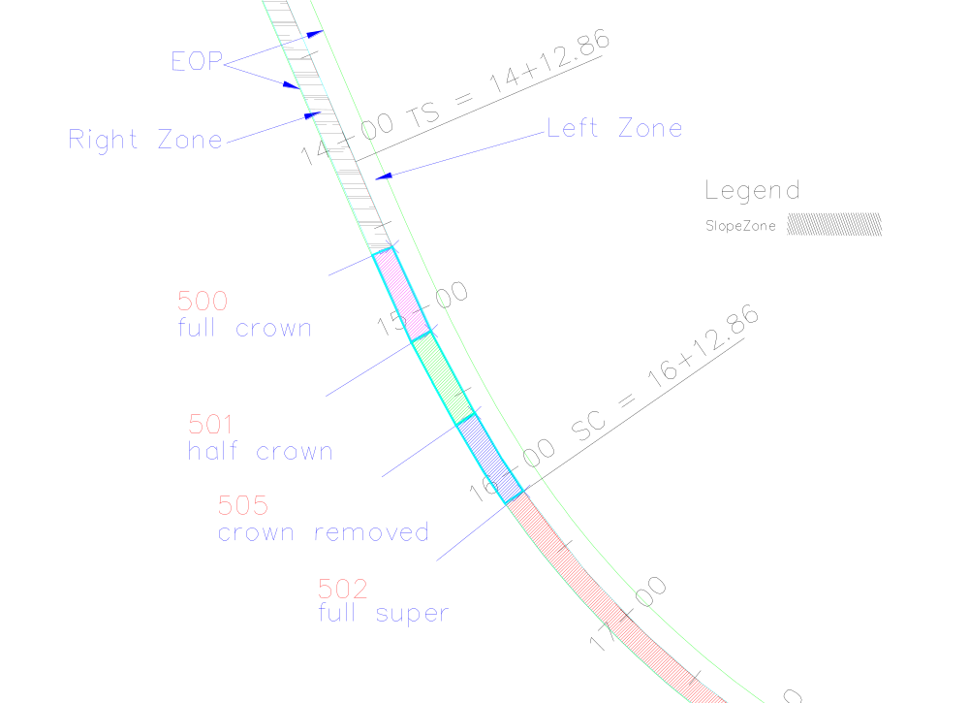

Describing Structural Roadway objects

Structural 3D objects can be described using the optional <Zone>.<ZoneCrossSectStructure> element. Examples of these types of objects are retaining walls, sound barriers, longitudinal barriers, channels, bridge abutments and vertical pillars.

<ZoneCrossSectStructure> is an optional child of <Zone>, which means, if it doesn't exist, the <Zone> element has the same line shape as in current <GradeModel>. If it is defined, as for example in zone 5 below, then the line shape is substituted by the polygon (or polyline), defined by a <PntList2D> containing cross-sectional offset / elevation pairs. Each <ZoneCrossSectStructure> has an innerConnectPnt and an OuterConnectPnt attribute, which uniquely connect the polygon to the adjacent zones. The connection points can be seen as the left (inner) and right (outer) edge of the basic zone shape.

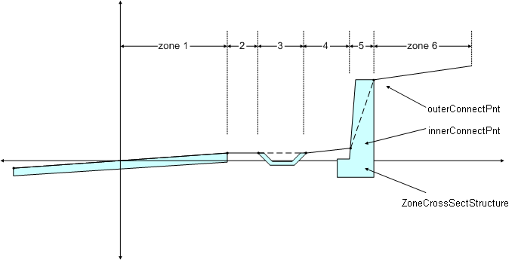

There are a few simpleTypes used to describe specific data types for this element.

<xs:simpleType name="zoneTransitionType">
<xs:restriction base="xs:string">
<xs:enumeration value="parallel"/>
<xs:enumeration value="linear"/>
</xs:restriction>
</xs:simpleType>

<xs:simpleType name="zoneOffsetType">
<xs:restriction base="xs:string">
<xs:enumeration value="centerline"/>
<xs:enumeration value="zone"/>
</xs:restriction>
</xs:simpleType>

<xs:simpleType name="zonePlacementType">
<xs:restriction base="xs:string">
<xs:enumeration value="dependent"/>
<xs:enumeration value="independent"/>
</xs:restriction>
</xs:simpleType>

The <ZoneCrossSectStructure> element is defined as

<xs:element name="ZoneCrossSectStructure">
<xs:complexType>
<xs:sequence>
<xs:annotation>
<xs:documentation>
The PntList2D contains space delimited offsetDistance / elevation pairs describing a crossectional shape, typically a closed shape representing a retaining wall, traffic barriers or vertical pillars. As is common with road cross sections the origin is the Profile Grade Line (PGL) of the design road. The offsetDistance measure is the 2D distance from the PGL and the elevation values are absolute (real world) elevations for the entire data set.</xs:documentation>
</xs:annotation>
<xs:element ref="PntList2D"/>
<xs:element ref="Feature" minOccurs="0" maxOccurs="unbounded"/>
</xs:sequence>
<xs:attribute name="name" type="xs:string"/>
<xs:attribute name="innerConnectPnt" type="crossSectionPnt" use="required"/>
<xs:attribute name="outerConnectPnt" type="crossSectionPnt" use="required"/>
<xs:attribute name="offsetMode" type="zoneOffsetType" default="zone"/>
<xs:attribute name="startOffset" type="offsetDistance" default="0.0"/>
<xs:attribute name="startOffsetElev" type="offsetElevation" default="0.0"/>
<xs:attribute name="endOffset" type="offsetDistance" default="0.0"/>
<xs:attribute name="endOffsetElev" type="offsetElevation" default="0.0"/>
<xs:attribute name="transition" type="zoneTransitionType" default="parallel"/>
<xs:attribute name="placement" type="zonePlacementType" default="dependent"/>
<xs:attribute name="catalogReference" type="xs:anyURI" use="optional"/>
</xs:complexType>
</xs:element>

Where the offsetMode attribute defines how a <ZoneCrossSectStructure> location is calculated and can have two values: "zone" and "centerline". If "zone" is selected, the location depends on the neighboring zone - which means in the same way as other <Zone> elements (if Offset and OffsetElev retain the default value 0.0). "Centerline" on the other hand means, that the location is calculated from centerline, not from the outside edge of the neighboring zone.

startOffset, startOffsetElev, and endOffset and endOffsetElev, define the offset from either the centerline or from the edge of the adjacent zone at the beginning and at the end of Zone.

The transition attribute defines the way of transition between the start and end station of a zone. If "parallel" is selected, the edges run parallel to the centerline, and if "linear", the points are connected in a linear way.

The next attribute, location, can be of use, if a zone represents an element that doesn't "move" with the centerline (location = "independent"). If for example a wall is defined on an optimal location and then the centerline gets refined it can be useful to let the wall on the old location.

